MSC “Upgrade” Aids Recovery from Brain Injury

February 15, 2015 | Mesenchymal Stem Cells
Mesenchymal stem cells (MSCs) have drawn much attention for their reparative properties, for example in the treatment of acute neurological injuries such as traumatic brain injury (TBI) [1]. Studies have found autologous administration of MSCs to be safe and feasible to promote neurological recovery in TBI patients [2], although strategies to improve efficacy are much sought after. Stromal cell‐derived factor 1 α (SDF1α) secretion from astrocytes and endothelial cells is high at the boundary zone of brain lesions [3], and researchers have now begun to assess whether overexpressing the SDF1α receptor CXC chemokine receptor 4 (CXCR4) in MSCs may mediate improved cell homing and engraftment. The results, published in Stem Cells, suggest that CXCR4 overexpression may represent a useful new therapeutic tool [4].
Lentiviral transduction of mouse MSCs generated cells which were 90% positive for CXCR4 expression (MSC-CXCR4), and migration co-culture assays demonstrated that the modified MSCs had enhanced SDF1α-mediated migration capabilities. The SDF1α-CXCR4 interaction also activated the Akt signaling pathway (a mediator of cell proliferation, migration and metabolism [5]), leading to high levels of VEGF which stimulates vasculogenesis and angiogenesis [6]. This level was high enough to promote human umbilical vein endothelial cell (HUVEC) tube reconstruction following disruption.
The researchers then moved to a controlled cortical impact mouse model, where high levels of SDF1α accumulated in damaged tissues 24 hours after TBI. MSC-CXCR4 administration at this point led to significantly more MSC-CXCR4 at the TBI site than the wild‐type MSCs at 48 hours, with most cells accumulating at the periphery of blood vessels around the boundary of TBI, with some evidence of migration and/or diffusion into the parenchyma. This resulted in higher VEGF expression and increased vascular density (see Figure), alongside higher levels of the neurotrophin BNDF which may allow for neuronal protection during TBI recovery. Excitingly, MSC-CXCR4 administration also led to extensive blood vessel reconstruction and blood perfusion at the periphery of injury site, significantly enhanced blood flow, and aided the recovery of conductivity following myelinated axonal injury. In line with these findings MSC-CXCR4 administration significantly improved functional recovery whereas MSCs had no such effect. Finally, the authors detected decreased levels of pro-inflammatory cytokines and increased levels of anti‐inflammatory cytokines in the mouse brain after stem cell administration, with a stronger effect noted after MSC-CXCR4 administration.
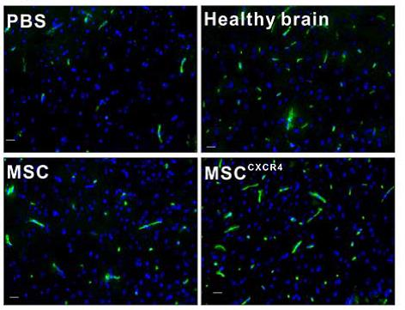
Overall, the overexpression of CXCR4 appears to boost the reparative effects of MSCs through enhanced MSC tropism and paracrine cytokine secretion, and the modulation of immune regulation. This paper, amongst many notable others, highlights the important role that cell engineering will have in the treatment of various diseases and disorders, making therapeutic interventions safer, better and more effective. Future engineering may be capable of boosting VEGF/BDNF levels, while further dampening the immune response, overall leading to an enhancement in therapeutic response. The MSC just got a few more upgrades, what else is in store?
References
- Harting MT, Jimenez F, Xue H, et al. Intravenous mesenchymal stem cell therapy for traumatic brain injury. J Neurosurg 2009;110:1189-1197.
- Zhang ZX, Guan LX, Zhang K, et al. A combined procedure to deliver autologous mesenchymal stromal cells to patients with traumatic brain injury. Cytotherapy 2008;10:134-139.
- Shen LH, Li Y, Chen J, et al. Therapeutic benefit of bone marrow stromal cells administered 1 month after stroke. J Cereb Blood Flow Metab 2007;27:6-13.
- Wang Z, Wang Y, Gutkind S, et al. Engineered Mesenchymal Stem Cells with Enhanced Tropism and Paracrine Secretion of Cytokines and Growth Factors to Treat Traumatic Brain Injury. Stem Cells 2014;
- Mangi AA, Noiseux N, Kong D, et al. Mesenchymal stem cells modified with Akt prevent remodeling and restore performance of infarcted hearts. Nature medicine 2003;9:1195-1201.
- Olsson AK, Dimberg A, Kreuger J, et al. VEGF receptor signalling - in control of vascular function. Nat Rev Mol Cell Biol 2006;7:359-371.

